**Ingredients:**

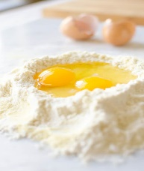

[This Photo](https://www.veryeatalian.com/how-to-make-fresh-pasta/) by Unknown Author is licensed under [CC BY-SA-NC](https://creativecommons.org/licenses/by-nc-sa/3.0/)

1. 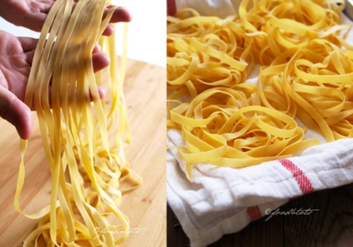3 cups sifted flour
2. 3 eggs
3. Approximately ¼ cup water

**Directions:**

1. Measure approximately 3 cups flour and sift onto wax paper
2. Measure 3 level cups of this sifted four and put on counter and form a well in the center of the flour.
3. Crack the eggs into the well. Whisk the eggs with a fork while slowly incorporating some flour into it to thicken it. Keep incorporating a little flour at a time until everything is combined – this can also be done by using the dough scraper and folding the flour and eggs and chopping into it. This will give you a crumbly or “shaggy” dough.
4. Knead the dough by folding and pressing with your palms, and turning for approximately 5 minutes until you have a well-blended and smooth ball of dough.
5. Divide the dough into at least 4 sections to run though the pasta machine. Wrap the dough you are not using in cling wrap as it will dry out quickly.
6. To toll your pasta using a pasta machine – first make sure the machine is clamped firmly.
7. Lightly dust the work surface with flour, take a lump of pasta dough the size of a large orange and press it out into an oval shape. Set the pasta machine at its widest setting - #7 - and roll the lump of pasta dough through it twice.
8. Lightly dust the pasta with flour on both sides.
9. Click the machine down a setting to #6 and roll the pasta dough through again. Pinch the pasta together to make a loop and roll again. Click to #5 and roll twice, click to #4 and roll twice. Be sure all this time that the pasta is properly floured.
10. Take the dough off by cutting it with the dough scraper.
11. Cut into approximately 12 inch strips.
12. Run it through the fettuccine noodle setting on the pasta machine.
13. Lightly dust with flour and make a nest of the noodles.
14. Put in Ziploc bag to freeze.